What is AWS Systems Manager (SSM)?
AWS Systems Manager is a management service that helps you:
- Manage EC2 instances
- Run commands remotely
- Patch servers
- Automate operational tasks
- Access servers securely
without using SSH.
Normally to manage an EC2 instance you:
- Open port 22
- Use SSH key
- Connect manually
With Systems Manager:
Let’s perform the hands-on
First let us launch an EC2 instance
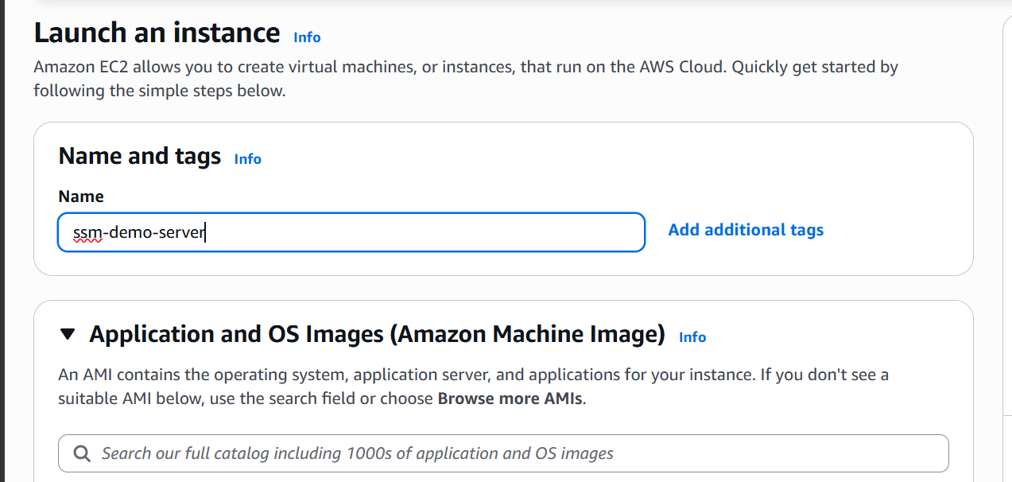
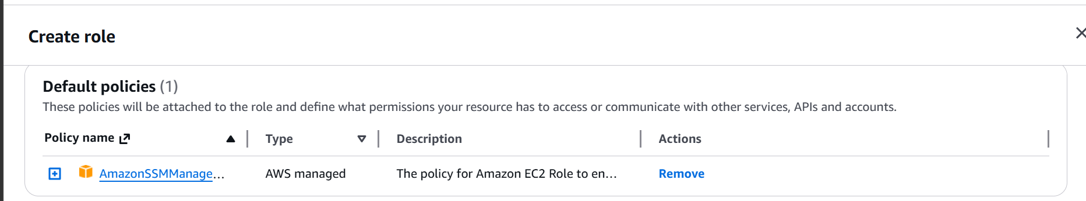

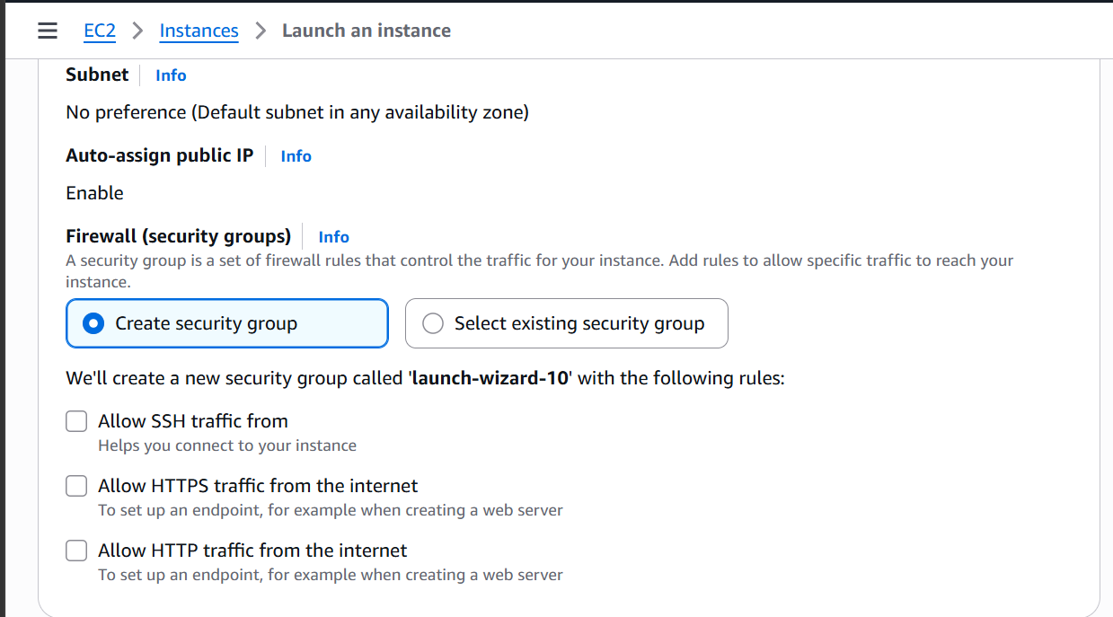

No ports open
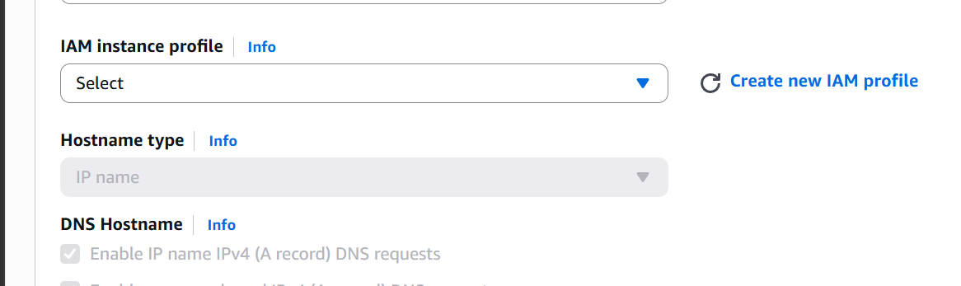
Click on create new IAM profile
Create a new IAM role
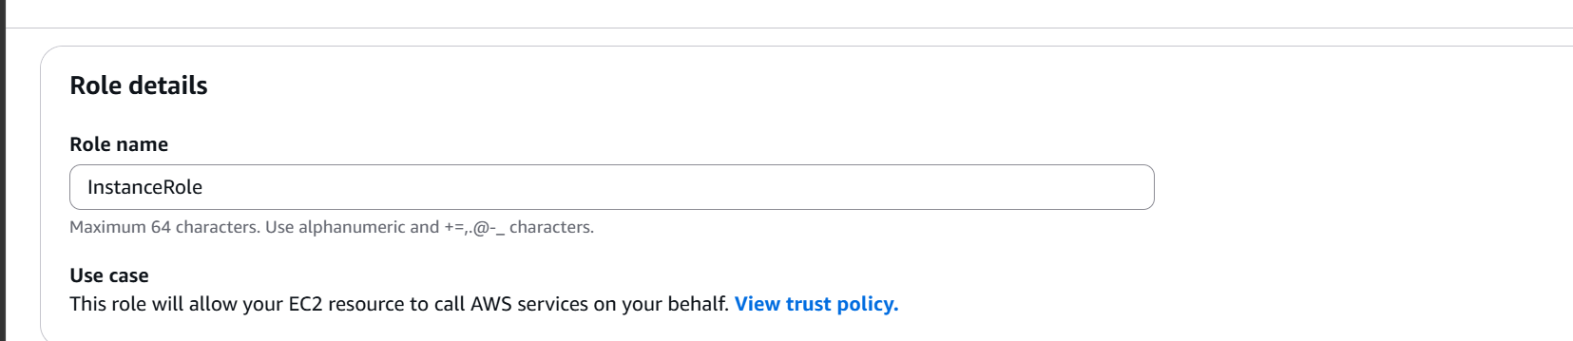
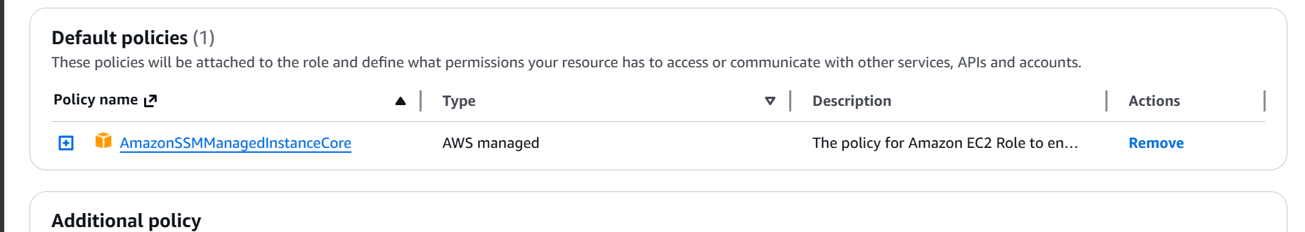
Attach the SSMManagedInstanceCore Policy
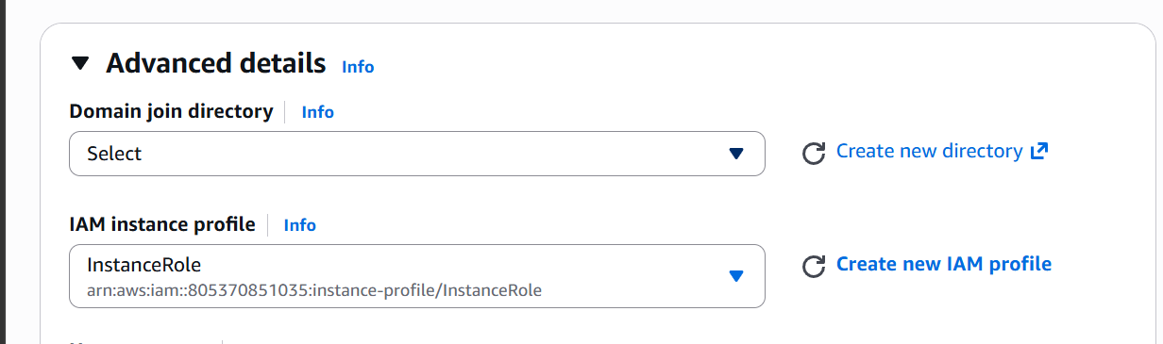

Select the role
Now launch instance

Now go to systems manager
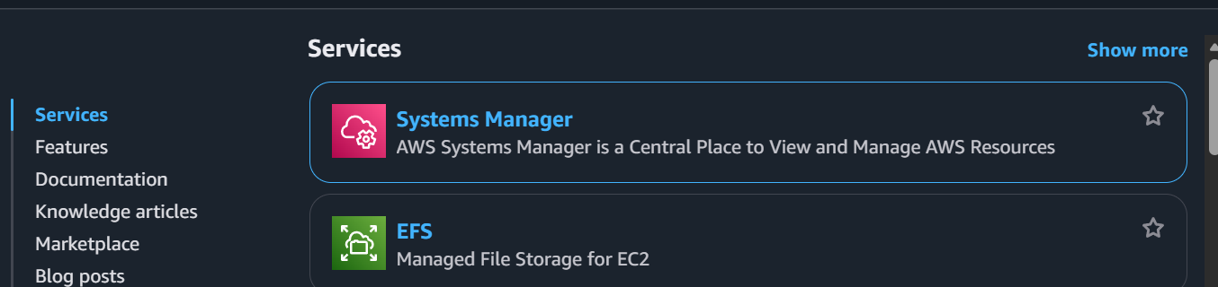
Go to fleet manager
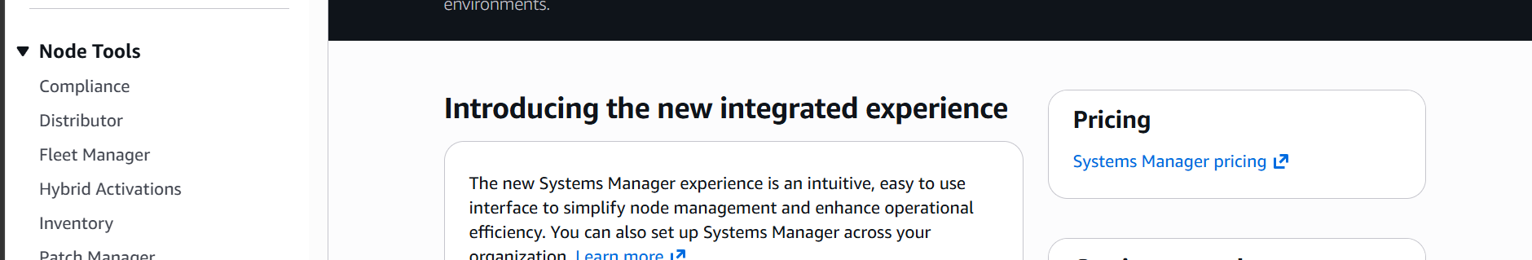

We can see our instance here
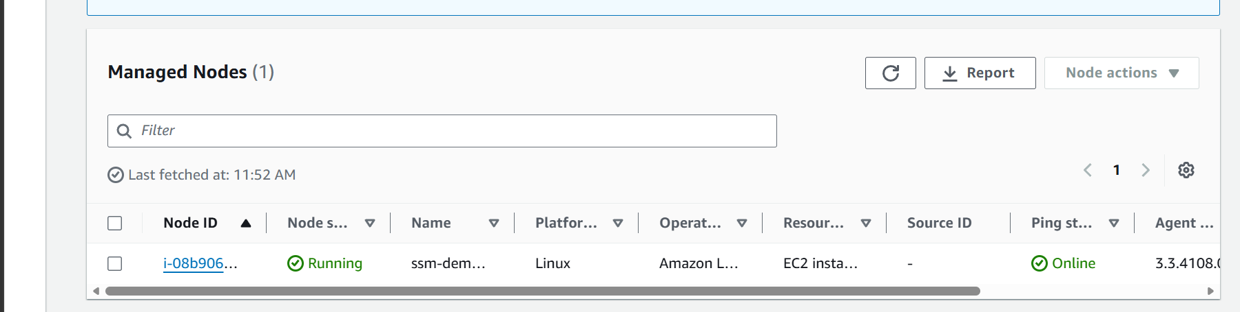
Now lets connect to the instance through SSM
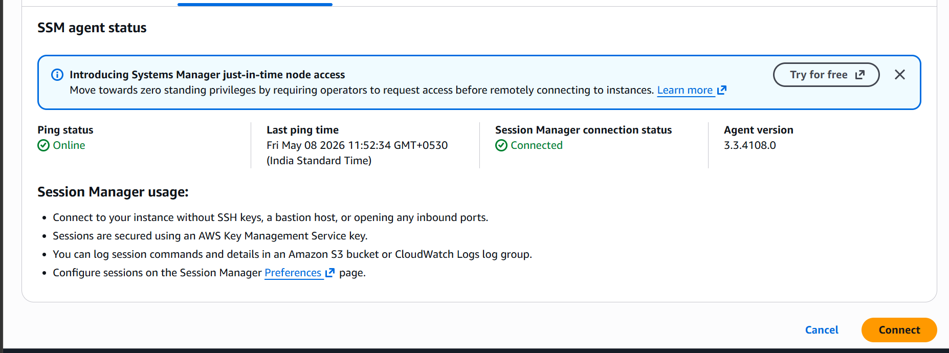
Ping status is online
Click on connect
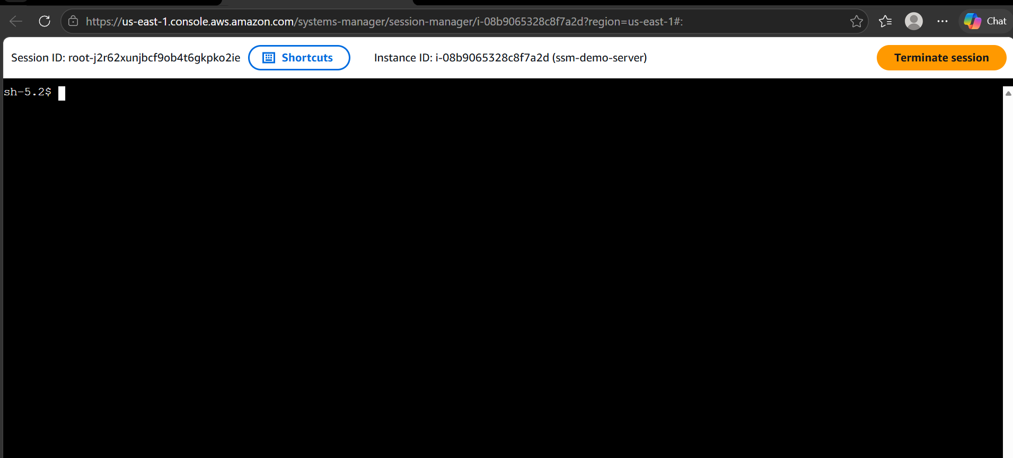
We are now able to connect to the instance without SSH without a pem file
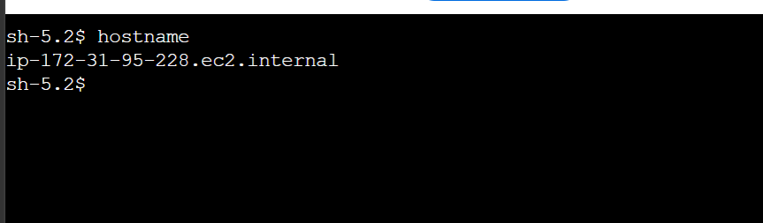
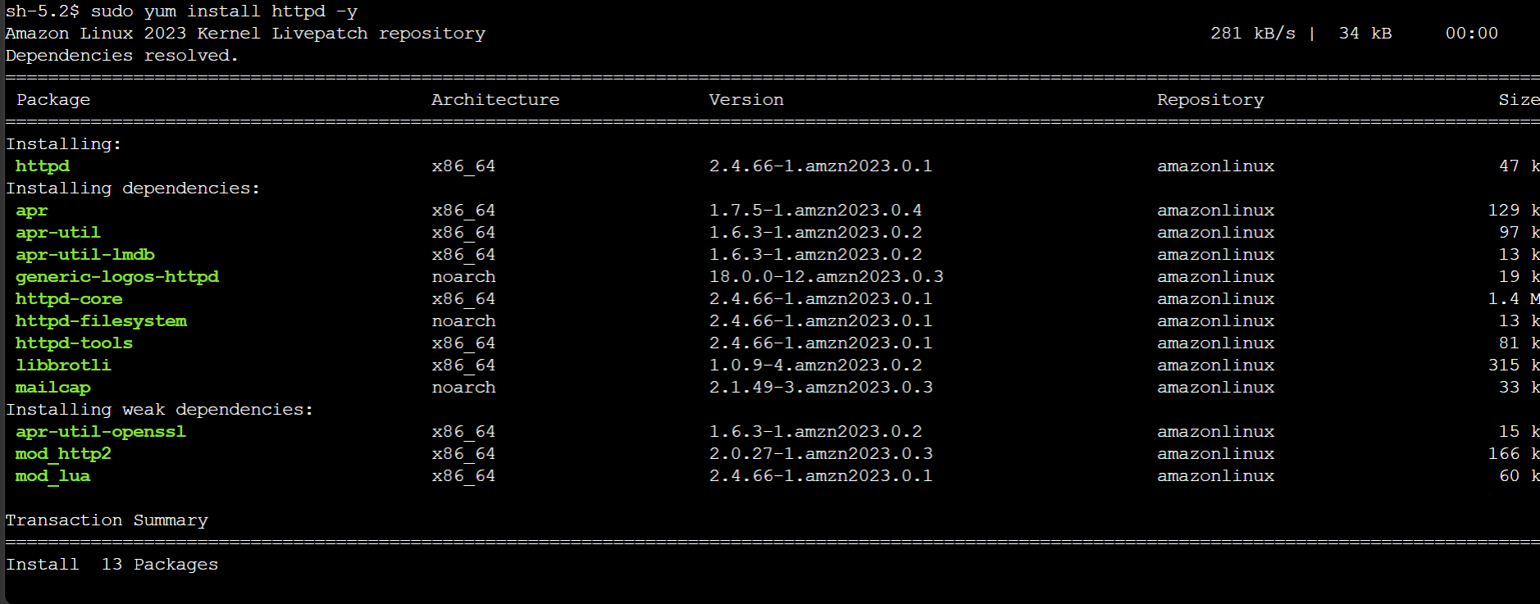
Able to access the internet as well.

